New Solution &
Potential Impact
Essay

Xianglong Ronaldo Lin (45791439)

Design for a Better World DSGN1500

Word Count: 1648

Introduction

Design is the representation of the human idea to solve the problem.

- The Representation of the Idea

Design is the process from problem discovery to solution, it is widely regarded as a fixed relationship. However, design is not programmed, and the problem is difficult to be directly put into a fixed process for analysis and solution. Many expressions of the design idea are triggered after mastering enough information, so design is the representation of the idea.

- The Human Idea

Design is based on the human idea and the construction of creating things, rather than the mechanised production. Design follows the certain steps to achieve the operation, but the order of the steps may have the corresponding adjustment based on the real static environment. This creates the iteration of the step, so these design processes incorporate the human intelligence, knowledge, and creativity. Combined with the previous statement, design is the representation of the human idea.

- To Solve the Problem

The design thinking is to solve the problem through the design, the problem solving needs to introduce the method, and condense all the solutions into relatively fit and relatively concise. In conclusion, the definition of design is the representation of the human idea to solve the problem.

Body of Text

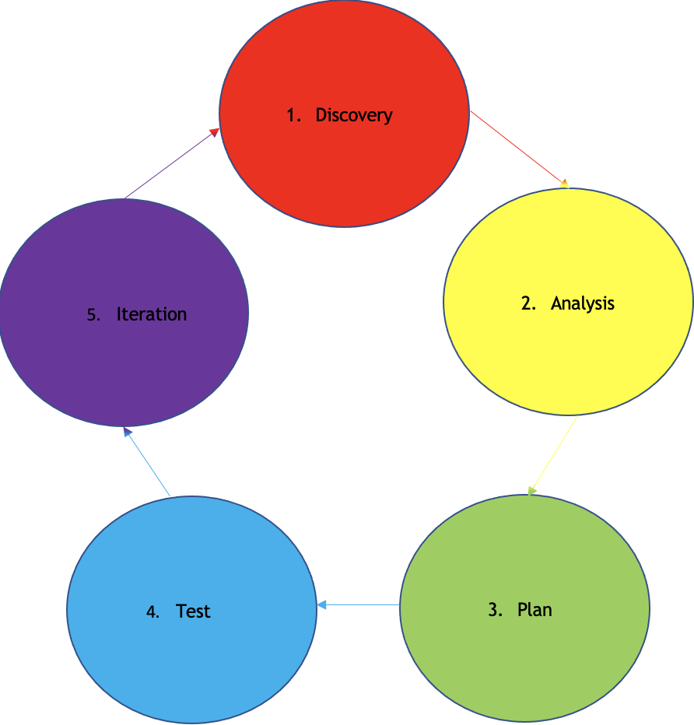
Figure 1. Design Process

My approach to solve the complex social problem is divided into 5 sections, and the order of the steps will be also adjusted accordingly to adapt to the problem due to the different contexts.

- Discovery: discover and define the problem.

To discover the problem is to know the existence of the problem. And to find the useful and valuable information from the numerous information outside. Albert Einstein proposed that to discover a problem is the essential to solve the problem. (1) This shows that to discover the problem is an innovative ability, and the solution is the follow-up execution. Albert Einstein also claimed that the problem can be solved by staying with the problem. (2) This presents that to discover the problem is to face the problem actively and take the responsibility to lay the foundation for the solution.

To define the problem is the first step in the design process, through which a preliminary understanding of the specific problem is obtained to analyse. And to diagnose the situation and shift the focus to the real problem. To define the problem can cover whether there is a problem and what problem exists. Albert Einstein said, “If I were given one hour to save the planet, I would spend 59 minutes defining the problem and one minute resolving it.” (3) This displays the key impact of defining the problem on the solution. The essential need leads to the generation of the problem. (4) This describes the views of the problem from the different perspectives determine how to analyse in the next step. There can be many ways to treat the problem, which leads to the different solution plan, because the order of the needs to be met is different. To define the problem may take more time than to implement the solution, but the appropriate solution can be more effectively found.

- Analysis: analyse and research the problem.

To analyse and research the problem is to clarify the nature and know the goal and the correlation. To analyse and research aims to have a better understanding of the problem. (5) This demonstrates that the solution can be made with less effort by the analysis and the research. The solution is likely to create a new problem when the original problem is not well understood. (6) This contains that the solution cannot be proved whether it is effective and targeted to the problem without the implementation. However, the analysis and the research are the guarantee before the implementation of the solution, and the solution becomes true and reliable only after meeting the analysis and the research. The usual method is to divide the problem and split the factors; then classify the factors to find the commonness and the characteristic; and finally, analyse and research the factors after arranging. So far, the decomposition of the problem from whole to local is achieved.

- Plan: plan and formulate the solution.

To plan and formulate the solution is to combine the need and the factor to get the preliminary solution. The appropriate plan can ensure the best strategy to achieve the goal. (7) This shows that the appropriateness of the plan and the formulation largely affects the establishment and the implementation of the solution, which sets the framework and the scope of the solution. So, the establishment between the problem and the need can be more focused on to reduce the interference and the impact from the excess external factor on a good solution, thus the probability of a new problem because of the solution is also reduced. After getting the need and the factor, the connection should be established through the plan and the formulation. There are many ways to establish the connection, but each way has the advantage and the disadvantage. Currently, it is necessary to list all the necessary considerations and weigh the advantage and the disadvantages and choose the best solution to narrow the solutions.

- Test: test and implement the solution.

To test and implement the solution determines and reflects the effect and the feedback of the solution. To test and implement the solution is the final step of solving the problem. Only after the result is obtained, the unmet need, the unconsidered factor, and the unestablished connection between the need and the factor are showed. So more valid background can be provided for the modification of the solution only by knowing the lack of the need, the factor, and the connection. The true knowledge comes from the practice. (8) This summarises that to test and implement the solution is the result of all the work and more important than the establishment because the advantage and the disadvantage are revealed to inform the suitability for the continued implementation or the modification. In this way, the creation of the new problem and the unsoundness of the solution can be greatly avoided. So, the solution is reliable and responsible after the test and the implementation.

- Iteration: iterate and develop the solution.

To iterate and develop the solution is the improvement of the solution and the continuous approach to the goal. The iteration allows the new solution to be created and tested. (9) This provides that the iteration is the trial-and-error process to make the solution become practical and the goal closer. The preliminary solution can only be based on the need and the factor given by the basic background, but the need and the factor may change, then the iteration develops the solution to dynamically adapt and be reasonably applied in the new problem, so that the balance between the need and the factor is still reliable. The iteration of the solution can be more flexible to reduce the risk and improve the efficiency. (10) This suggests it is usually difficult for the solution to fit the best at once, but the iteration reduces the possibility of the new problem and provide a better knowledge of the solution effectiveness. This greatly improves the efficiency of the new solution. And the new solution must also undergo the new iteration, so that the goal and the reality are constantly matched.

Conclusion

The design principle is the consideration of the solution from the designer in addition to the problem. So, the principle defines the nature of the solution. The followings are the top 3 principles that a responsible designer should have:

- Intention

The Intention implies the design purpose is good and clear. The good intention refers to not only the beautiful appearance of the product, but also the beautiful original intention and desire. And the clear intention refers to the clear design idea. The good and clear intention determines that the result is favourable to the society and accepted by the public. The design must be people-oriented. (11) This indicates that the design should be based on serving the people. The result is the performance of the intention, the good intention determines the right direction of the thing, the clear intention makes the implementation easier and more reliable, so that the solution can be acceptable. The beauty and the clarity of the design intention ensures the correctness of the solution to be people-oriented and responsible.

- Reliability

The reliability means the normal, accurate, and stable performance of the design function. So, the reliability is related to the design quality. The reliability also includes the durability and the maintainability. The durability refers to the long use time and the maintainability refers to the corresponding fault detection and troubleshooting can be applied after the problem to remain the normal operation. The reliability is to ensure that the product performs the specific function in the given environment within the desired cycle. (12) This gives that the design structure becomes more complex with the increasing factor and need. Meanwhile, the reliability, the durability, and the maintainability complement each other. Therefore, the reliability is to ensure that the solution can also play the due function in the due time length to achieve the due role, so that the feeling to the people is comfortable and responsible.

- Sustainability

The sustainability is the balance and the coordination between the need and the future development. The sustainability requires less unnecessary resource consumption, and the use of the recyclable and sustainable material, thereby minimizing the waste and environmental damage. The sustainability maintains the ecosystem and the natural resource to ensure the life quality. (13) This indicates that the unsustainable design is likely to cause the irreversible harm to the environment and the nature and create the new problem. Therefore, the sustainability is necessary for the responsibility to the people and the nature.

References (Vancouver)

- Ellis L. [Internet]. Today in Science History. Todayinsci; [cited 2022Nov9]. Available from: https://todayinsci.com/E/Einstein_Albert/EinsteinAlbert-ProblemQuote500px.htm
- Gray JP. It’s A Gray Area: Einstein’s brilliant thoughts pertinent to today’s woes. Daily Pilot. 2013May31;
- Spradlin D. Are You Solving the Right Problem? [Internet]. Harvard Business Review. 2012 [cited 2022Nov9]. Available from: https://hbr.org/2012/09/are-you-solving-the-right-problem#:~:text=%E2%80%9CIf%20I%20were%20given%20one,it%2C%E2%80%9D%20Albert%20Einstein%20said
- Brown SI. The Logic of Problem Generation: From Morality and Solving to De-Posing and Rebellion. The Logic of Problem Generation: from Morality and Solving to De-Posing and Rebellion. 1984Feb;4:10.
- Nicholas J. The 5 Steps in Problem Analysis [Internet]. Business Analyst Mentor. 2022 [cited 2022Nov9]. Available from: https://businessanalystmentor.com/problem-analysis/
- Dolfing H. Understanding Your Problem Is Half the Solution (Actually the Most Important Half) [Internet]. Blogger; 2018 [cited 2022Nov9]. Available from: https://www.henricodolfing.com/2018/05/understanding-your-problem-is-half.html#:~:text=When%20the%20problem%20is%20not,the%20problem%20won't%20recur.
- How to Build a Strategy in 6 Steps [Internet]. OnStrategy; 2022 [cited 2022Nov9]. Available from: https://onstrategyhq.com/resources/building-plan/
- Chen-hsiang L. True Knowledge Comes from Practice [Internet]. Peking Review. 1972 [cited 2022Nov9]. Available from: https://www.marxists.org/subject/china/peking-review/1972/PR1972-32b.htm
- Design iteration brings powerful results. So, do it again designer! [Internet]. The Interaction Design Foundation. Interaction Design Foundation; 2021 [cited 2022Nov9]. Available from: https://www.interaction-design.org/literature/article/design-iteration-brings-powerful-results-so-do-it-again-designer#:~:text=Iterative%20design%20allows%20designers%20to,heart%20of%20the%20design%20process.
- Awati R. What is iterative? [Internet]. Search Software Quality. TechTarget; 2022 [cited 2022Nov9]. Available from: https://www.techtarget.com/searchsoftwarequality/definition/iterative
- People Oriented Design [Internet]. Informit. Architecture Australia; 2019 [cited 2022Nov9]. Available from: https://www.informit.com/
- What is Reliability? [Internet]. ASQ. American Society for Quality; 2022 [cited 2022Nov9]. Available from: https://asq.org/quality-resources/reliability
- Why Is Sustainability Important? [Internet]. BluGlacier; 2022 [cited 2022Nov9]. Available from: https://bluglacier.com/why-is-sustainability-important/#:~:text=Sustainability%20improves%20the%20quality%20of,to%20logistics%20to%20customer%20service.
Appendix
